1. **Agenda**:
   1. Attributes of Messages, Queues, Exchanges.
   2. 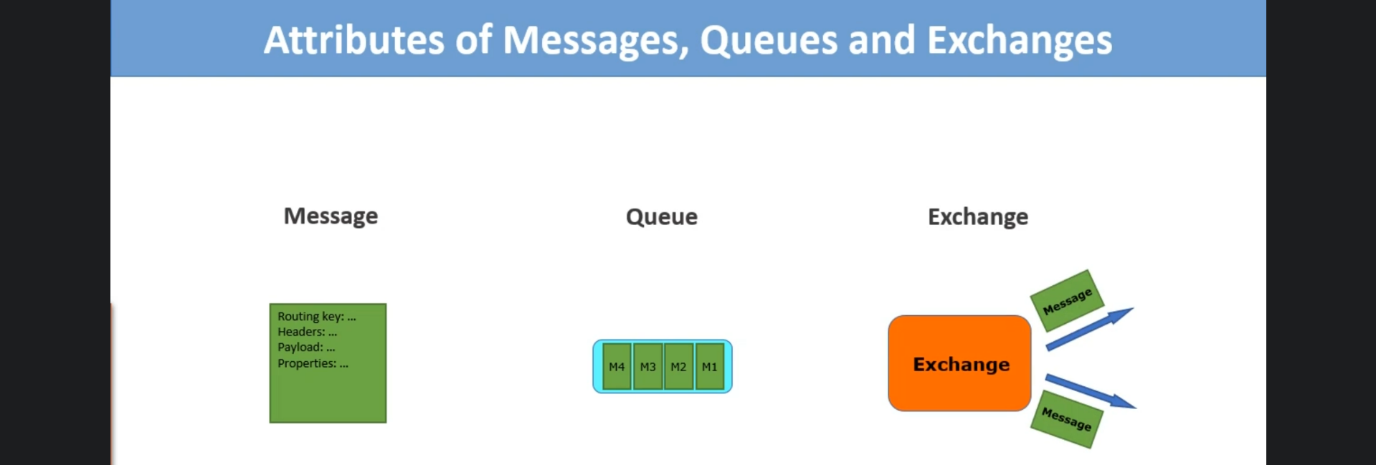
2. 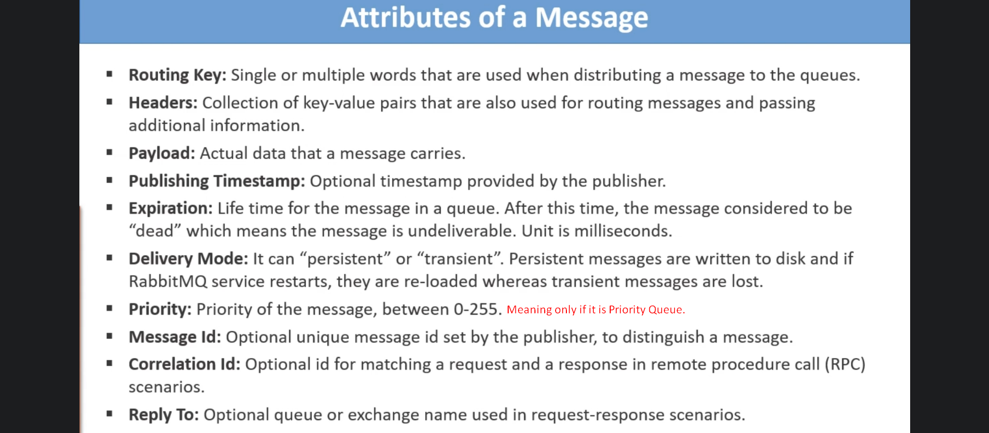
3. 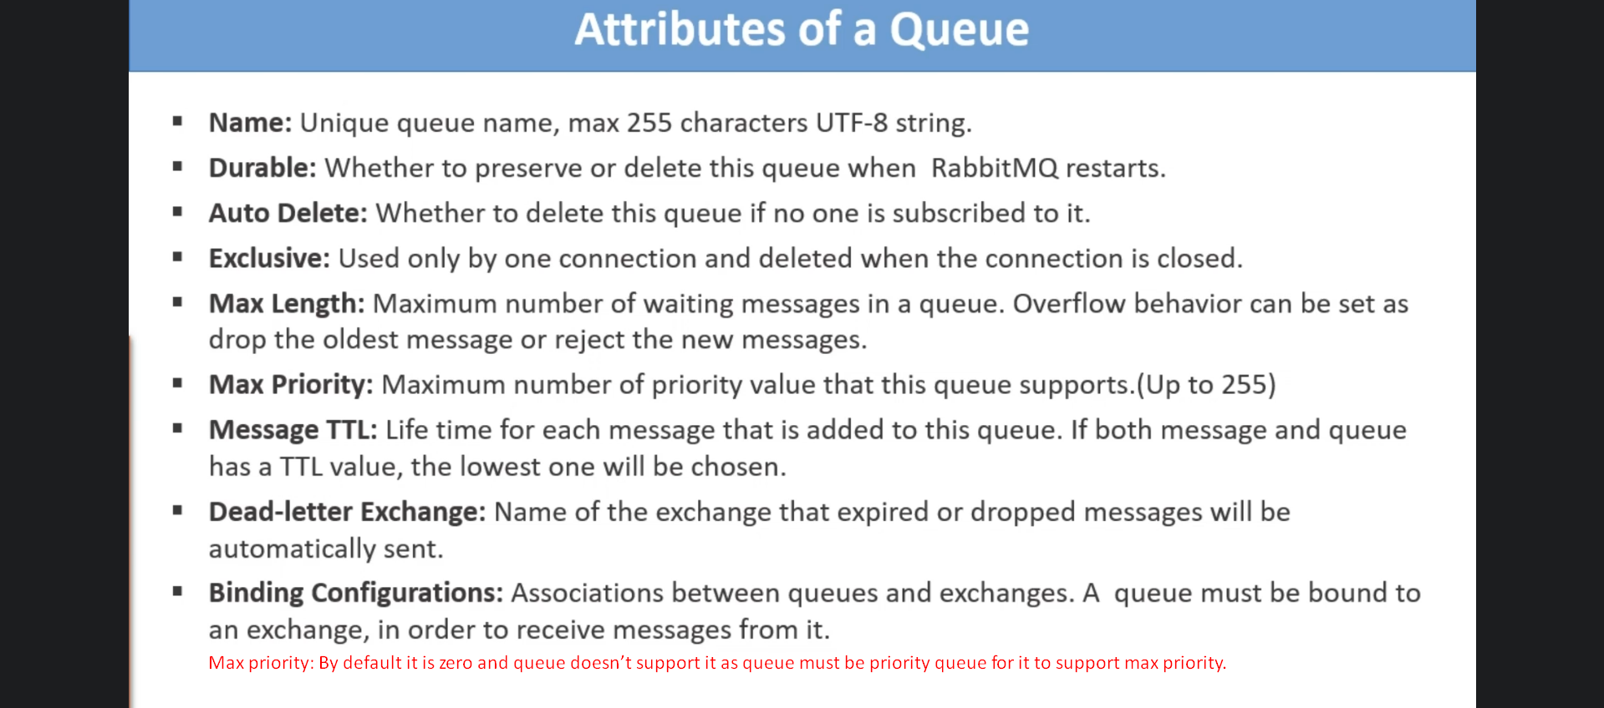
4. 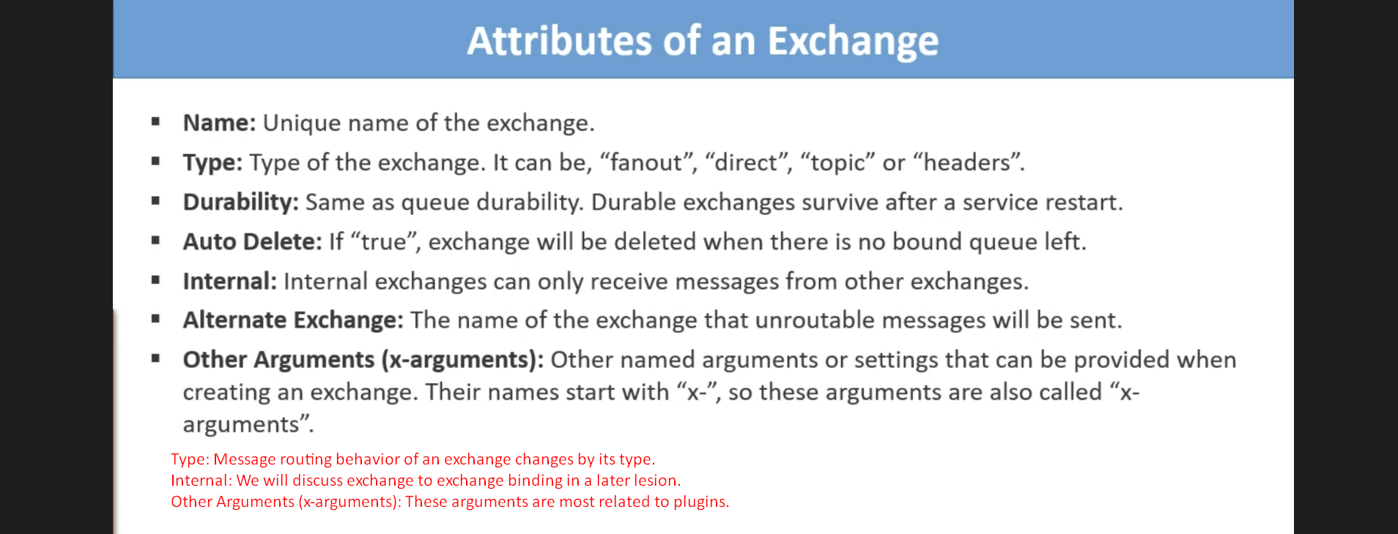
   1. Auto Delete: The exchange will be deleted when no queue or other exchange is bound to it.
   2. Internal: Publisher applications can’t send msg directly to this exchange but other exchange can send.  
      It is closed to outside world but can’t be used by other exchange.
   3. Arguments: To configure several change behaviors.
   4. Alternative Exchange: Msg is routed to this exchange when a msg can’t be routed to any other exchange.  
      